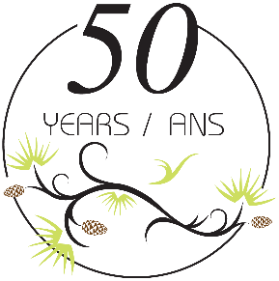
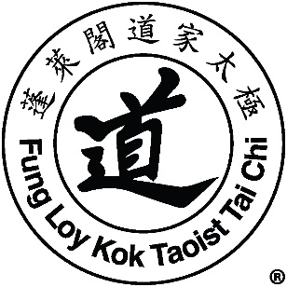
Welcome to the International Center Florida
CIT Week – January 8th – 12th, 2020
Lok Hup Week – January 13th – 17th, 2020
International Program/Pain Relief – January 20th – 24th, 2020

Registration:
CIT Week: Tuesday, January 7th 3:00 PM – 6:00 PM
Wednesday, January 8th 8:00AM – 9:30 AM

Lok Hup Week: Sunday, January 12th 2PM – 5PM
Monday, January 13th 8:30AM – 9:30AM

International Program/Pain Relief: Monday, January 20th 8:30 AM – 9:30 AM

Meals:
Dinner will be served at the Center on Tuesday, January 7th at 6PM at no cost.

Breakfast, lunch, and dinner will be served Wednesday, January 8th through Thursday, January 16th for $10 each lunch and/or dinner, and $5 each breakfast. Only breakfast and lunch will be served on Friday, January 17th, as the Lok Hup Week program ends at 2PM. There may be a night out for dinner during each of the two weeks.

For International Program/Pain Relief Week, only lunch will be served each day. Dinners will be out on our own. The program ends on Friday, January 24th at 2 pm.

Parking:
No onsite parking is available at the Center. Parking is available in the parking lot at the Dunedin Main Library (223 Douglas Avenue, Dunedin, Florida 34699).
Please park as close to Douglas St as possible. No street parking is allowed.

Hotels:
Please be aware that the hotel rate at the Fenway has increased from $110 USD per night to $114.70 USD per night.

Emergency Numbers:
Call 911 for all MEDICAL emergencies.
For all other emergencies, call 877-398-1108 or Sean Dennison at 850-443-8527.

