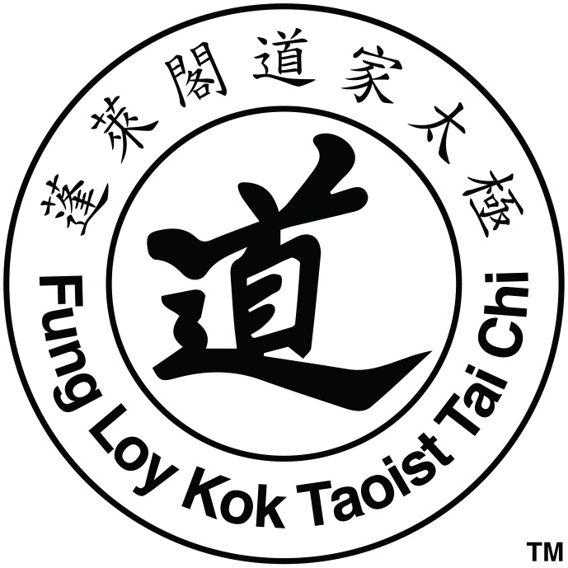
Taoist Tai Chi Society of the USA
International Center Florida
Grand Opening, November 3, 2018, 3 p.m.
Schedule of Events

Event Overview

The Taoist Tai Chi Society of the USA is celebrating the opening of its first International Training Center in the United States in Dunedin, Florida on Saturday, Nov. 3, 2018 beginning at 3 p.m.

Event festivities include free tai chi classes and demonstrations, food and drink, music, and performances by one of the largest Chinese dragons in North America.
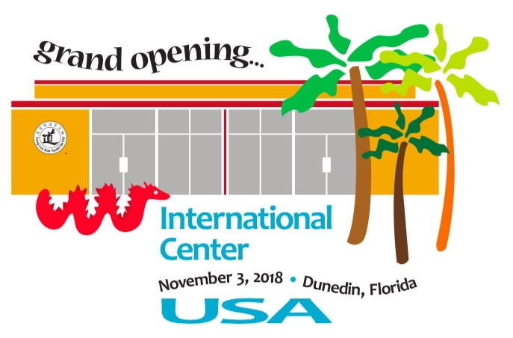
A ribbon cutting will take place at 4 p.m. and a sunset tai chi demonstration on the front lawn of the recently opened Fenway Hotel will begin at 5:30 p.m.

Event attendees can also visit the newly renovated Fenway Hotel from 5 - 6:30 p.m.

For more information visit www.taoisttaichi.org

Schedule of Events

3 p.m. Event festivities begin, including free tai chi classes and demonstrations, music, food & drink
4 p.m. Ribbon cutting
5 p.m. Chinese dragon will lead tai chi members over to the Fenway front lawn
5:30 p.m. Sunset tai chi demonstration on the front lawn of the Fenway Hotel
7 p.m. Dinner for the tai chi members back at the center (not open to the public)

Fenway Hotel Open House from 5-6:30 p.m.

There will be activities taking place prior to 3 p.m., but the majority of activities open to the public begin at 3 p.m.

